Week8_Branching and Merging (GitDemo)

Objective:
Construct a branch, do some changes in the branch, and merge it with master.
Phase 1: Initial Git Configuration
Step 1: Verified Git Version
git version
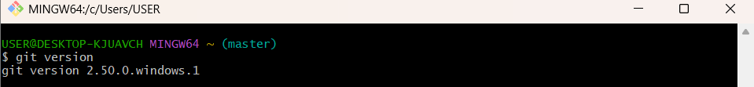
Step 2: Set Your User Name: This name will be associated with your commits.
git config --global user.name https://github.com/SaguturuShruthi
Step 3: Set Your User Name: This email will be linked to your commits.
git config --global user.email krishnashruthi2004@gmail.com
Step 4: Configured User Information
git config --global --list

Phase 2: Environment Setup: Integrating Notepad++
Step 5: Confirmed notepad++ Command Not Found Error
Step 6: Added Notepad++ to Environment Path
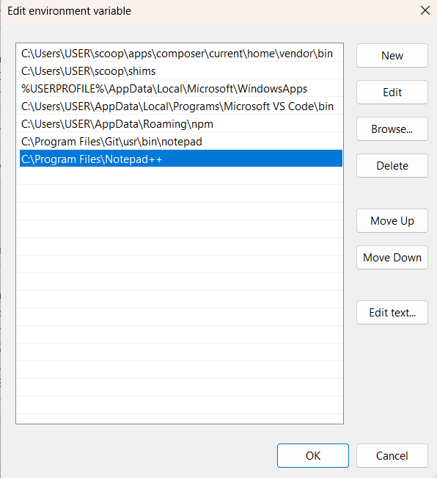
Step 7: Set Notepad++ as Git's Core Editor
git config --global core.editor "notepad++.exe -multiInst -nosession"

Step 8: Verify the Editor Configuration: To confirm the setup, run this command.
git config --global -e
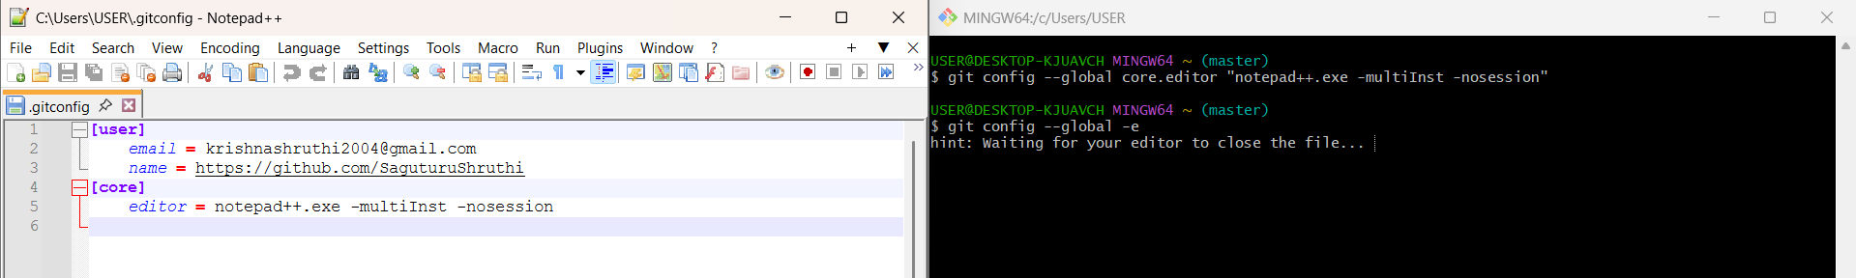

Phase 3: Branching
Step 9: Created and Listed New Branch:
- Created GitNewBranch.
- Listed all branches. The * indicates the current branch is master.
git branch -a
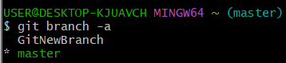
Step 10: Checked out GitNewBranch to make it the active branch.
git checkout GitNewBranch
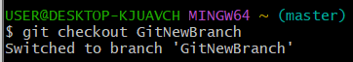
Step 11: Committed New File to Branch: Added feature.txt and committed it to GitNewBranch.

git add feature.txt
git commit -m "Add feature.txt to GitNewBranch"
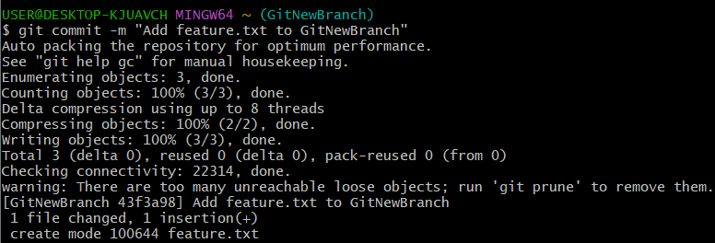

Phase 4: Merging
Step 12: Switched back to master: Used difftool to visually compare master and GitNewBranch.
git difftool master GitNewBranch
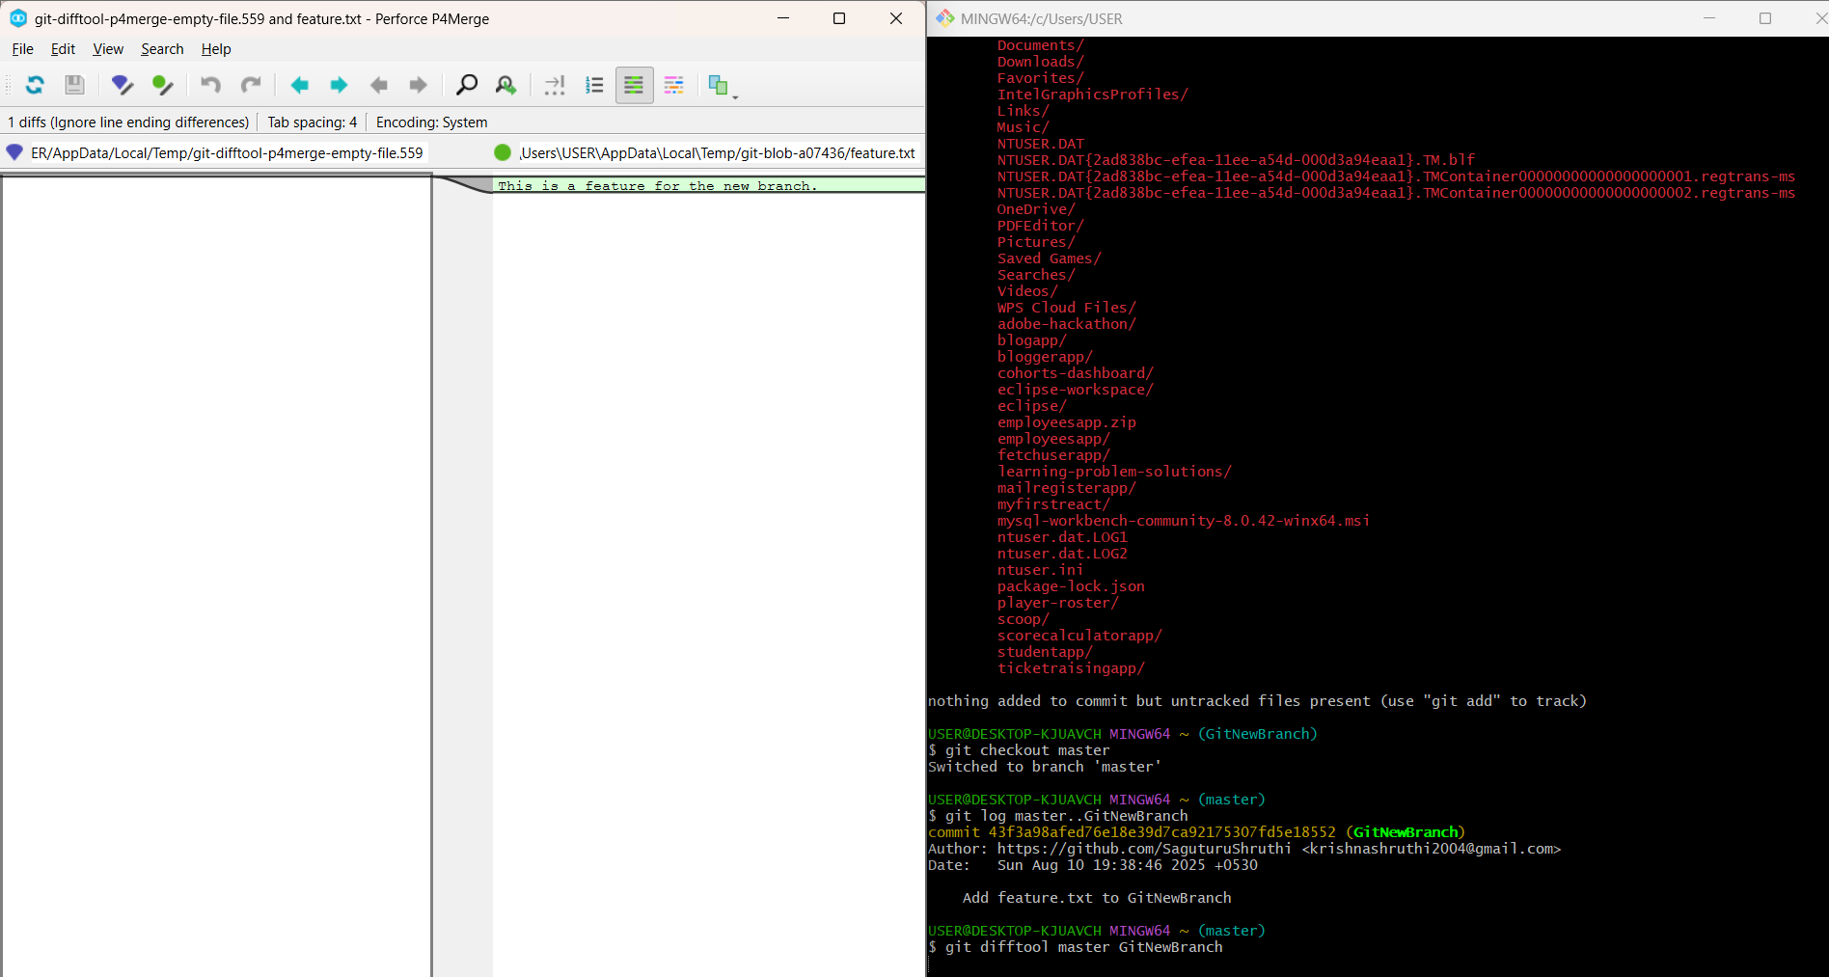

Step 13: Merged Branch into Master: Executed the merge command to bring changes from GitNewBranch into master.
git merge GitNewBranch
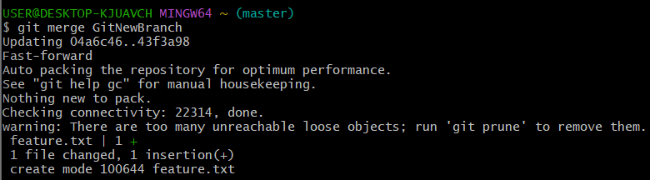
Step 14: Viewed the commit history with a graph, showing both branches pointing to the same commit post-merge.
git log --oneline --graph --decorate
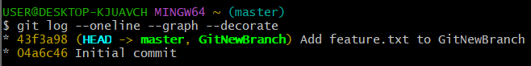
Step 15: Deleted Feature Branch: Deleted the now-merged GitNewBranch.
git branch -d GitNewBranch
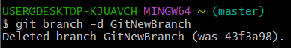
Fiinal Verification:
